**Strategic Safeguarding: Beyond Compliance - A Holistic Approach to Child Well-being**

Leaders of Safeguarding can **'Level Up Your Safeguarding Game BEYOND COMPLIANCE'** by focusing on the "Why," "How," and "What" of safeguarding, inspired by Simon Sinek's Golden Circle model:

**1. The 'Why': Re-articulating the Vision for Safeguarding**

At the heart of an effective safeguarding strategy is a clearly articulated 'Why' – a compelling vision that inspires action and commitment from all stakeholders. This goes beyond simply meeting legal requirements to enabling every child's full potential and well-being.

* Beyond Compliance: The core message is to "Level Up Your Safeguarding Game BEYOND COMPLIANCE." Safeguarding should not be seen as a mere checklist but as a fundamental commitment to children's "wellbeing, flourishing, and enabling potential."
* The Golden Circle Model: Inspired by Simon Sinek, the approach advocates starting with the 'Why' (Vision and values), then the 'How' (Process), and finally the 'What' (Products or services). This "taps into the part of the brain that influences behaviour and decision-making, fostering deeper connections and inspiring action, rather than just conveying information."
* Crafting a Vision: Organisations are encouraged to "Craft Your Personal/Organisational Safeguarding 'Why' Statement." This statement should be concise and explicitly include elements of "wellbeing, flourishing, and enabling potential," serving as a "guiding star" for all safeguarding efforts.
* Alignment Check: Current safeguarding policies and practices should be reviewed through the lens of this new 'Why' statement to ensure they "truly serve our Why" and are not "purely compliant, but don't actively contribute to wellbeing and flourishing."
* **'Voice & Influence' Pathways**:
  + **Actionable Takeaway**: Systematically assess how genuinely children/service users and staff can **voice concerns, provide feedback, and influence safeguarding practices** within your organisation. This means moving beyond passive methods to active engagement.
  + **Impact**: This empowers individuals, helps identify blind spots, builds trust, and makes safeguarding truly responsive to the needs of those it serves. It aligns with the principle of prioritising child-centred and family-focused practice and keeping the voice of the child at the heart of decisions.

### **The How -Self-Evaluation Exercise**

* **Utilise the 'INTELLIGENCE / DATA and REPORTING' Evaluation Grid**: As part of your reflective audit, use the provided evaluation grid to self-assess your organisation's current standing in key areas:
  + **Integrated Intelligence Sharing**
  + **Child-Centered Improvement**
  + **Regular Reporting and Excellent Recording**
  + **Continuous Dynamic Learning**
  + **Proactive Trend Analysis** For each area, score your organisation from 0 (Statutory Compliance) to 5 (Sector-Leading).
* **Identify Actions to Raise Your Score**: Once you have scored your current position, focus on the "LOWEST SCORING AREA" and the "2nd LOWEST SCORING AREA". For these areas, specifically

outline **"ACTIONS TO RAISE SCORE BY 1"**. This practical step will help you move from basic compliance towards more advanced and sector-leading safeguarding practices.

* **THE WHAT - Adopt a 'Flourishing Focus' (Beyond Incidents)**:  
  + **Actionable Takeaway**: Identify and implement one or two new, non-incident-based indicators to **measure the positive impact of your safeguarding efforts on wellbeing and flourishing**.
  + **Examples**: This could include regular, anonymised student/service user surveys about feelings of safety, belonging, and happiness; tracking staff wellbeing and confidence in safeguarding processes; analysing trends in attendance and engagement data; or gathering qualitative feedback that illustrates positive change.
  + **Impact**: This shifts the focus from solely deficit-based reporting to measuring success in creating positive, enabling environments.

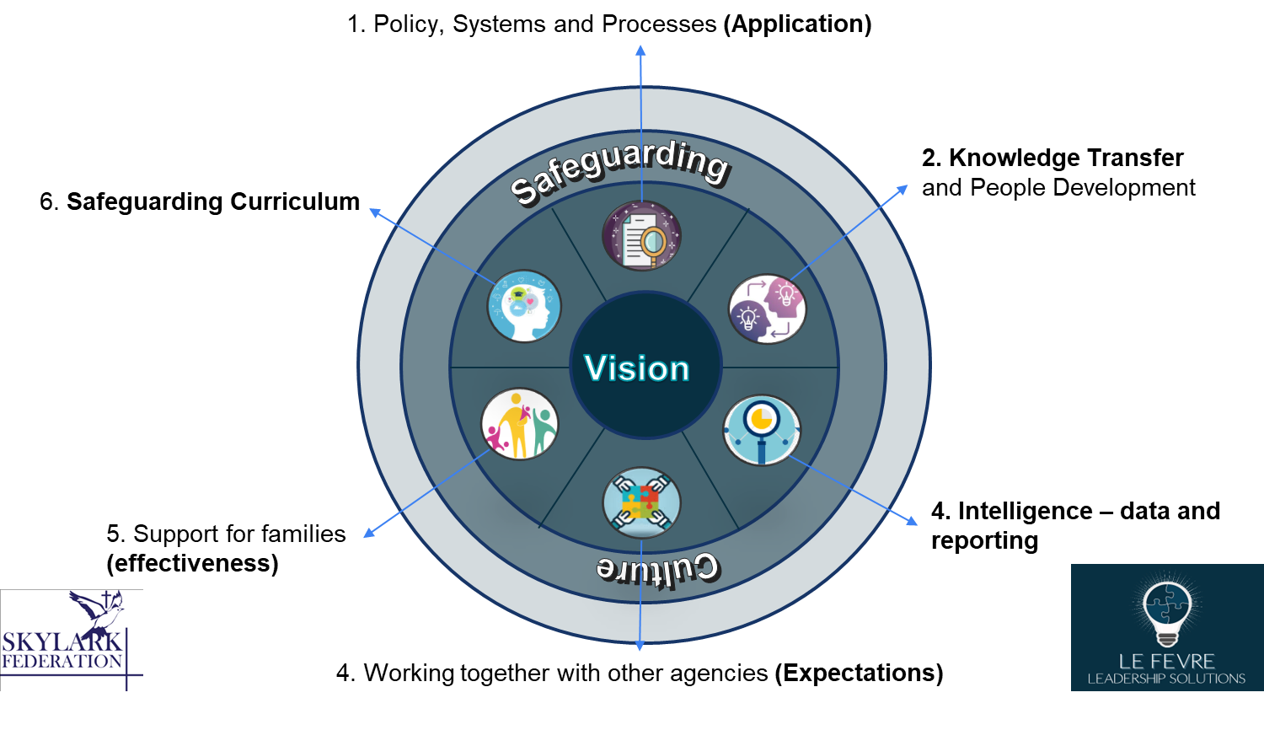

**More Info found at** [**https://www.lefevre-solutions.co.uk/leadership-solutions/strategic-safeguarding/**](https://www.lefevre-solutions.co.uk/leadership-solutions/strategic-safeguarding/)

